CS 255 System Design Document
DriverPass System Design
Prepared by: Richard Savage

UML Diagrams
This system design document uses a blended object and process modeling approach for the DriverPass system. The design supports DriverPass customers, administrators, secretaries, and driving instructors by combining online training, appointment scheduling, user management, payment handling, and progress tracking in one organized system.

UML Use Case Diagram
The use case diagram shows the main groups that will interact with DriverPass and the major services each group needs. Students can create an account, buy a training package, schedule driving lessons, complete online practice exams, and view their progress. Staff members can manage appointments, users, lesson records, and reports. The system also connects to outside services for payments and DMV-related updates.
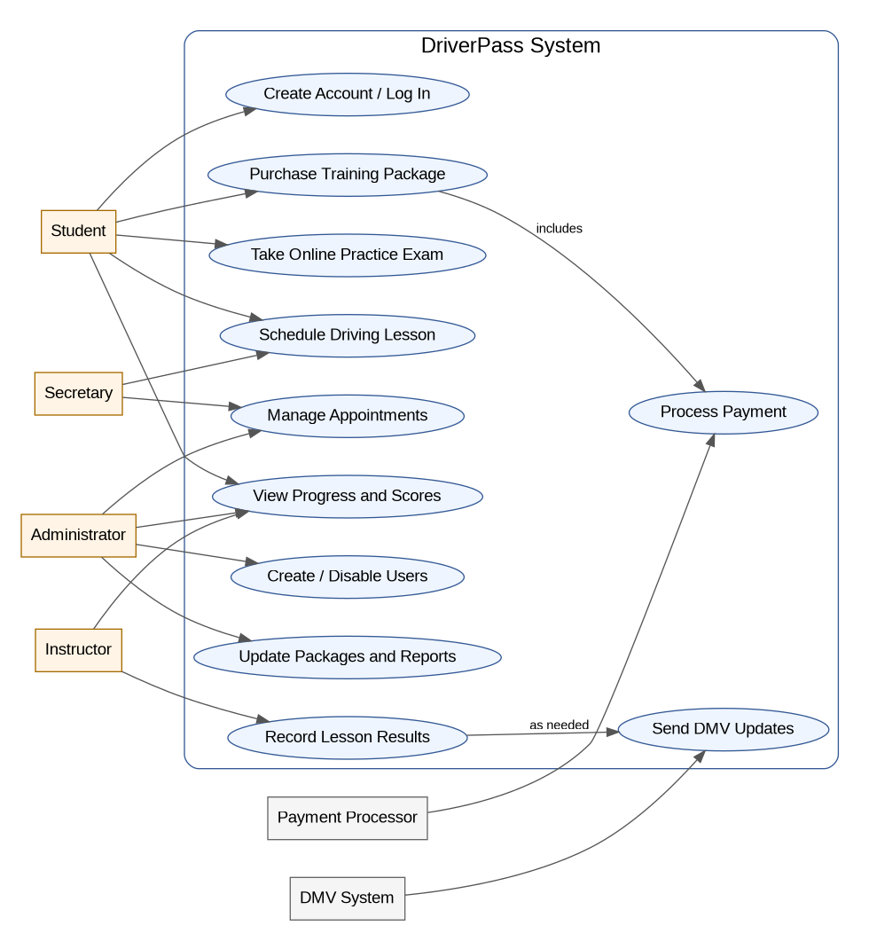
Figure 1. DriverPass UML Use Case Diagram

UML Activity Diagrams
The first activity diagram breaks down the scheduling process. It begins when a student logs in and chooses a lesson type. The system checks instructor, vehicle, and time availability. If the selected time is not available, the student is shown other options. If the time is available, the lesson is reserved and confirmations are sent.
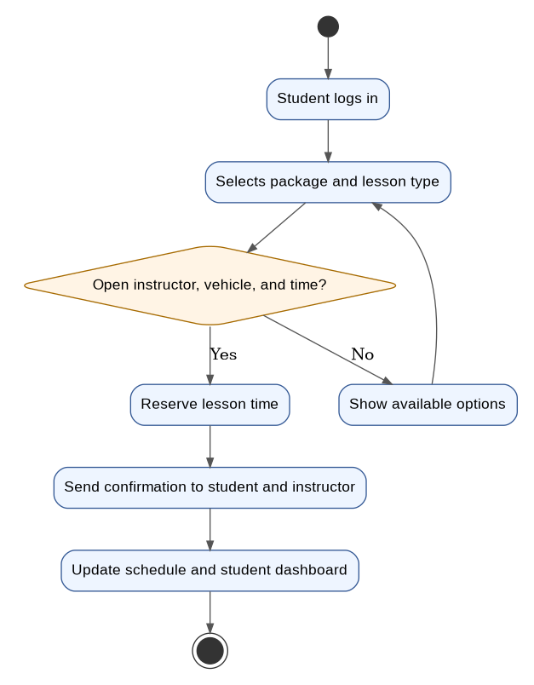
Figure 2. Activity Diagram: Schedule a Driving Lesson
The second activity diagram explains the online practice exam process. A student logs in, chooses a practice exam, answers the questions, and submits the exam. The system scores the results, stores them in the student record, and gives the student either a readiness update or a recommendation to continue reviewing.
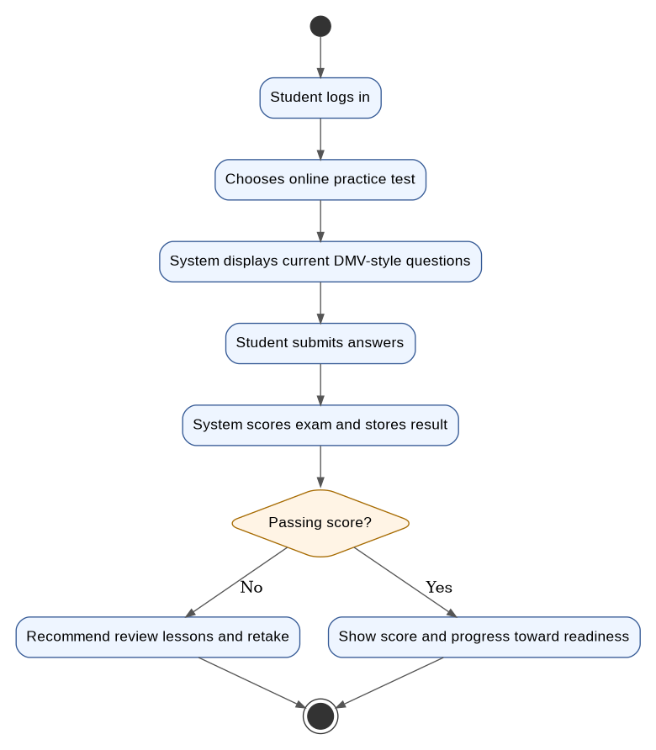
Figure 3. Activity Diagram: Take an Online Practice Exam

UML Sequence Diagram
The sequence diagram focuses on the schedule a driving lesson use case. It shows the order of communication between the student, the web portal, the scheduling service, instructor calendar, vehicle calendar, and notification service. This view helps developers understand how the system should check availability before confirming an appointment.
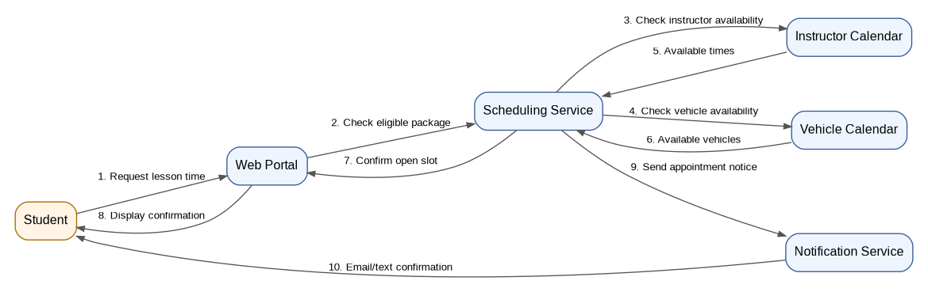
Figure 4. Sequence Diagram: Schedule a Driving Lesson

UML Class Diagram
The class diagram identifies the major objects and data the DriverPass system needs to store. The system centers on users, students, staff, appointments, vehicles, packages, payments, practice exams, questions, and progress reports. These classes give the development team a starting point for the database structure and application code.
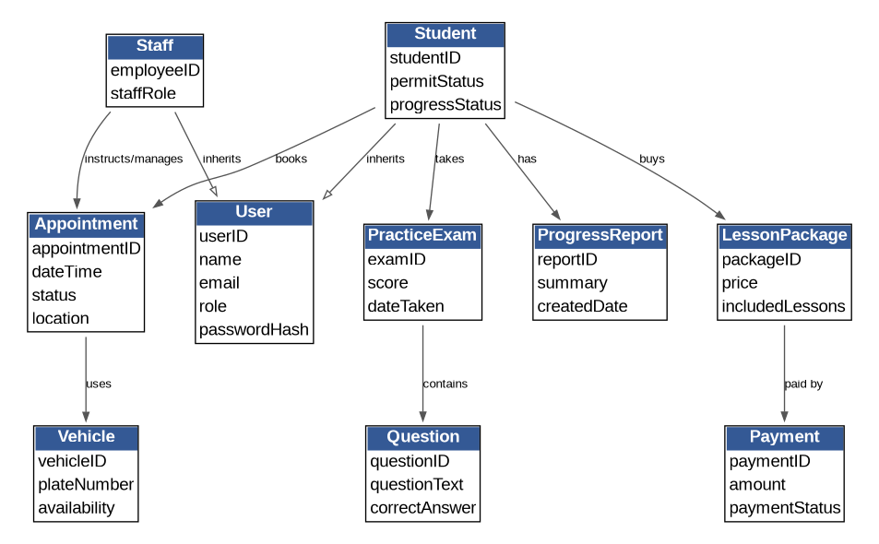
Figure 5. UML Class Diagram

Technical Requirements
The DriverPass system should be built as a secure web-based application so customers and staff can access it from common devices without installing special software. The following technical requirements describe the hardware, software, tools, and infrastructure needed to support the proposed design.

Hardware Requirements
- Cloud-hosted web and database servers to support customer accounts, appointments, practice tests, payments, and reports.
- Reliable office computers or laptops for administrators, secretaries, and instructors who manage schedules and review student progress.
- Student access through personal computers, tablets, or smartphones with an internet connection.
- Backup storage for system data, reports, student records, appointment history, and audit logs.

Software Requirements
- A web application with separate views for students, administrators, secretaries, and instructors.
- A relational database to store users, roles, appointments, vehicles, lesson packages, payments, practice exam results, and progress reports.
- Role-based access controls so each user only sees the information and tools needed for their job or customer account.
- A scheduling module that checks instructor, vehicle, and time availability before confirming lessons.
- A practice exam module that stores current DMV-style questions, scores student attempts, and updates progress records.
- A reporting module that allows staff to view customer progress, lesson completion, and appointment activity.

Tools and Development Requirements
- Lucidchart or another CASE tool for maintaining UML diagrams and system documentation.
- A modern development environment such as Visual Studio Code, Eclipse, or IntelliJ IDEA for implementation.
- A version control platform such as GitHub so the development team can track changes and collaborate safely.
- Testing tools for unit testing, integration testing, user acceptance testing, and security testing before release.
- Project tracking tools such as Jira, Trello, or Azure Boards to manage system features, fixes, and implementation tasks.

Infrastructure and Security Requirements
- Encrypted website traffic using HTTPS to protect logins, account details, payments, and student records.
- Secure payment processing through a trusted payment provider rather than storing full payment card details inside DriverPass.
- Regular database backups and a recovery plan to reduce data loss if a failure occurs.
- Logging and monitoring so unusual login activity, failed payments, schedule conflicts, and system errors can be reviewed.
- Administrative controls for creating, disabling, and updating staff and student accounts.
- Regular software updates and security patches for the web application, server environment, and database platform.

Summary
This design gives DriverPass a practical system structure that supports its core business needs. Students receive an easy way to buy packages, schedule driving lessons, take practice tests, and track progress. Staff members receive the tools they need to manage users, appointments, instructors, vehicles, lessons, and reports. The technical requirements also support security, reliability, and future growth as DriverPass adds more customers and services.

